CaixaBank Term Deposit Telemarketing Campaign Analysis, Visualization and Strategic Roadmaps
1. Project Overview
This project analyzes historical customer interactions and current campaign attributes from 45,211 telemarketing data points. The goal is to explore customer behavior patterns to uncover factors that influence a customer’s decision to subscribe to a term deposit and build insights for future marketing strategies.

2. Dataset Summary
- Rows: 45,211
- Columns: 20
- Key Features:
- Customer demographics (Age, Job, Marital Status, Education)
- Financial Considerations (Balance, Housing, Loan, Default)
- Marketing Campaign Features (Contact, Duration, Campaign)
- Missing Data: No missing data in all columns

3. Exploratory Data Analysis using Python
We began with data preparation and cleaning in Python:
- Data Loading: Imported the dataset using pandas.
- Initial Exploration: Used df.info() to check structure and df.describe() for summary statistics.
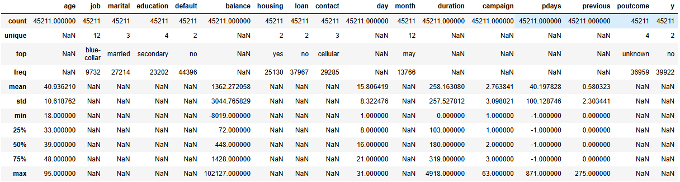

Feature Engineering:
- Created duration_min column and converted duration from seconds to minutes.
- Created age_group column by binning customer ages.
- Created month_number to show months in month column number.
- Column Standardization: Renamed column y to deposit for better readability and understanding.

- Data Consistency Check: Verified if any column were redundant; or needed to be dropped if it will not be helpful to the analysis.

- Database Integration: Connected Python script to MS SQL and loaded the cleaned DataFrame into the database for SQL analysis.

Words Used In The Project

Word | Meaning
Subscription Rate  same as  Subscribers | Number of customers who were contacted and subscribed to bank’s term deposit.
Bounce rate  same as  Non-Subscribers | Number of customers who were contacted but didn’t subscribed to bank’s term deposit

Data Analysis using SQL (Business Transactions)
We performed structured analysis in MS SQL to answer key business questions:

- 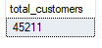
Customers: As at the time of campaign, CaixaBank has a total of 45,211 customers.

- 
Campaign Contacts/Calls: The telemarketing team conducted a total of 124,956 total outreach call volume over the course of the entire marketing campaign, with some customer phones dialed multiple times.

- 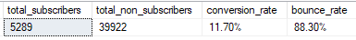
Subscriber’s vs. Non-Subscribers – Exactly 5,289 customers said "yes" and successfully subscribed to a term deposit while a massive majority of 39,922 customers said "no". Revenue-generating group (subscribers) for the bank amounts to 11.70% vs. 8830% (Non-Subscribers). This high number highlights a major optimization opportunity.

- 
Average Account Balance: Across all 45,211 customers targeted in this campaign, the overall baseline average balance is ($1,362.27). Average Balance of Subscribers is ($1,804.00), $501.00 more cash sitting in their accounts than non-subscribers. Customers who turned down the offer have a lower average account balance of $1,303.00 and unwilling to lock up their cash in term deposit because of other obligations.

Grand Summary – Summarized the entire marketing campaign performance data across the year to give a single, unified view. Summarized as follows;
- Months Count (12)
- Overall total unique customer population (45,211) for the 12 months
- 5,289 successful subscriptions across the entire year.
- 39,922 total lost opportunities or rejections across the entire year.
- Grand Rates - Subscribers vs. Non-Subscribers (11.70% vs. 88.30%)

- 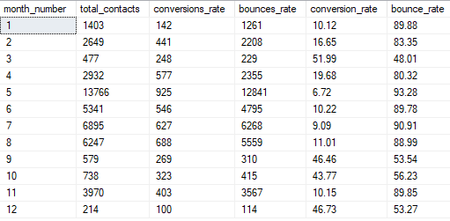
Subscription Rate by Month – Analyzed subscription rate (subscribers) vs. bounced rate (non-subscribers) on a month by month basis, analysis show that marketing campaign performance changes dramatically depending on the month.
Key takeaways from analysis:
- The May Volume Spike (Month 5): The marketing team executed an enormous amount of work in May, making 13,766 total contacts (nearly 30% of the entire year's volume). However, this month was highly inefficient, yielding the lowest Subscription Rate of the year (6.72%). The team was chasing quantity over quality.
- The Peak Efficiency Months (Months 3, 9, 10, 12): March, September, October, and December are the banks golden periods.
- March reached a staggering 51.99% Subscription Rate.
- September, October, and December all maintained Subscription Rates above 43%.
- The Strategy: Call volumes in these months were very low (under 800 contacts each). This proves that highly targeted, smaller campaigns during these specific months perform vastly better than mass-dialing in May.

- 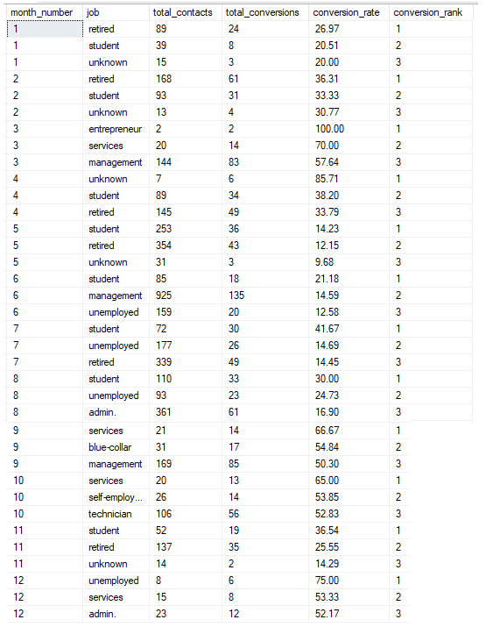
Subscription Trend by job type for the period – Compared all the job type for the period, to see which job type should be prioritized or replicated on low converting job types for future campaign.
Key takeaways from analysis:
Students and Retired
- Students and Retired customers dominate this list. Out of the 12 months in the year, Students hit the Top 3 list 8 times, and Retired individuals hit it 6 times.
- The Performance: In Month 1 and Month 2, Retired and Students lock down the exact #1 and #2 rank spots, consistently clearing a 20% to 36% Subscription Rate. In Month 11, Students convert at a massive 36.54% (Rank 1).
The Low-Volume Anomalies Category (Handle with Care!)
Our analysis reveals a few extreme spikes that happen because the call volume (total_contacts) was incredibly tiny.
- Month 3 (Entrepreneur - 100%): The telemarketing team called exactly 2 entrepreneurs and both said yes. While technically Rank 1, this is an outlier due to a tiny sample size.
- Month 4 (Unknown - 85.71%): Only 7 contacts were made to people with an unknown job, resulting in 6 conversions.
- Month 12 (Unemployed - 75.00%): Only 8 contacts were made.
While these are great wins, they cannot sustain a massive bank campaign because the audience size is too small.
The Sudden Shifts (Months 9 & 10)
- In September (Month 9) and October (Month 10), the pattern shifts completely away from students and retirees. Instead, Services takes Rank 1 (converting at 66.67% and 65.00%), while Blue-Collar (54.84%) and Self-Employed (53.85%) enter the Top 3.
Why this matters: This indicates a massive seasonal or target-list shift in the fall. The lists used in September and October were highly qualified, proving that when the data quality is excellent, even traditionally low-converting groups like Blue-Collar can crush performance expectations.
Direct Impact to the Banks Term Deposit Strategy/Action Plan
Create a continuous marketing and sales system designed to capture, nurture, and convert two dominant demographic groups—students and retirees—into long-term customers, 24/7: Because Students and Retired customers win almost every single month; they should be placed into an automated, year-round marketing pipeline. They are the banks baseline for highly predictable, low-risk revenue.

Exposing the Volume Bottleneck: For month 11 (November), students converted at 36.54% but the team only called 52 students. Meanwhile, the team wasted time calling thousands of other profiles.
Action:
Double or triple the dials to students in November, the banks total sales volume will skyrocket.

Replicate the Month 9 & 10 for Services and Blue-Collar: Investigate exactly what data list or offer was used for Services and Blue-Collar workers in September and October. Whatever special campaign or script was run during those two months was a success and should be scaled up.

- 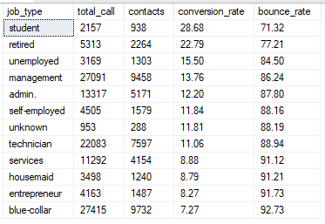
Overall Subscription Rate vs. Bounce Rate by job type – Compared all job type to identify which one to prioritize. Key findings; TIERING

Priority 1: The High-Performing Low-Hanging Fruit (Students & Retired)
Why: These segments have the highest willingness to convert.
- Students (28.68%) and Retired individuals (22.79%) are the banks absolute best converters. They are locking in deposits at double or triple the rate of other groups.
- Business Action: The bank should heavily target these two segments. Retirees likely have savings they want to grow safely, while students might be responding well to specific high-interest savings marketing or parental-backed accounts.
Action: This 2 segment are likely looking for low-risk, secure financial vehicles for tuition savings or fixed-income preservation. Create tailored messaging emphasizing financial security (for retirees) and short-to-medium-term savings growth (for students).

Priority 2: The Mid-Tier Corporate Base (Management & Admin)
Why: This segments Subscription Rates are moderate but has high volume
- Management (13.76%) and Admin (12.20%) fall right around the bank campaign's global baseline average (~11.7%). They represent steady, predictable revenue, with a massive chunk of the banks audience pool (over 14,600 contacts combined). A tiny increase in their conversion efficiency results in a huge surge of actual deposit volume.
- Business Action: Keep marketing to them, but look at what products they are being offered to see if you can optimize the messaging.
Action: Allocate a healthy budget here but implement stricter segmentation. Use personalized email tracks or targeted digital ads to lift their 12–13% baseline performance.

Priority 3: The Efficiency Drain (Blue-Collar)
- Blue-collar workers are at the absolute bottom of the list at 7.27%. In this specific dataset, blue-collar workers usually make up one of the largest volume of phone calls.
- Business Action: This represents a massive operational inefficiency. The sales team is wasting an incredible amount of time calling blue-collar leads for very little return. Marketing should pause or drastically reduce phone campaigns to this segment, or change the product offering entirely.
Job type significantly influences term deposit Subscription Rates. Total conversions are driven by (high Subscription Rate) and high volume (total contacts).

To maximize ROI, marketing campaigns should prioritize groups using a tiered strategy rather than just lo
- Action: Create tailored messaging emphasizing financial security (for retirees) and short-to-medium-term savings growth (for students).

Priority 2: High-Volume Revenue Engines (Management & Admin)
Why: While their Subscription Rates are moderate (Management at 13.76%; Admin at 12.20%), they represent a massive chunk of the banks audience pool (over 14,600 contacts combined). Even a tiny increase in their conversion efficiency results in a huge surge of actual deposit volume.
- Action: Allocate a healthy budget here but implement stricter segmentation. Use personalized email tracks or targeted digital ads to lift their 12–13% baseline performance.
Priority 3: Optimization Required (Blue-Collar)
Why: This is the banks largest segment (9,732 contacts), but it performs the absolute worst with a dismal 7.27% Subscription Rate and a 92.73% bounce rate. Spamming this list with the current strategy is wasting money and burning leads. It performs the absolute worst with a dismal Subscription Rate and bounce rate.

- Action: Deprioritize massive phone/outreach campaigns to this group. Instead, run small A/B test groups with alternative product offerings (like flexible withdrawal terms) to see if the bank can break the low conversion trend before scaling.

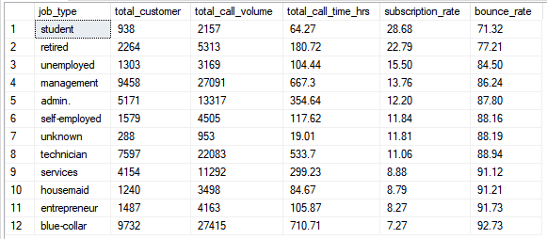
Operational Imbalance
Subscription Potential vs Call Time (hrs) by Job Type
- "Call Hours" Disconnect: Compared to their massive subscription potential the best-converting segments Student 28.68% & Retired 22.79 did not get enough call hours. Out of tens of thousands of marketing calls, Students and Retirees got a very small fraction of the overall outreach.
- Over-Targeting the Wrong Groups: The vast majority of the campaign's call volume and staff hours are traditionally poured into middle-aged professional segments like Blue-collar workers or Services. Ironically, these groups usually stay below a 10% subscription rate, resulting in massive wasted call hours and a high bounce rate
Recommendation
Sales team spent thousands of hours talking to demographics that consistently said "no," while only spending a handful of hours on Students and Retirees who eagerly said "yes". Reallocate call hours away from underperforming professional segments and shift that time toward student and retired or other high performing demographics to maximize total campaign revenue.
Action Plan for telemarketing team and Caixa stakeholder
Implement a Priority Tier for the customer segment for Term Deposit Subscription
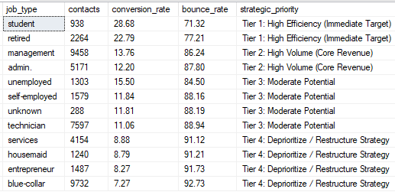
- Tier 1 (High Efficiency): Students and retired people show the highest Subscription Rates, making them the best immediate target for quick wins despite smaller overall numbers.
- Tier 2 (High Volume): Management and admin workers generate large contact volumes and strong core revenue returns, balancing out moderate success rates.
- Tier 3 (Moderate Potential): Unemployed, self-employed, unknown, and technician roles yield average conversion results requiring standard effort.
- Tier 4 (Low Return): Blue-collar, services, and entrepreneur roles show lower conversion efficiency and should be deprioritized or restructured.

Recommendation
Prioritize Tier 1 and Tier 2 categories for the banks main marketing campaigns to maximize both success percentage and total subscriptions.

Monthly performance of telemarketers- Analyzed the average of what the yearly performance is by month. Key findings;
- Marketing team reaches out to roughly 3,768 customers. This represents the team's monthly operational capacity.
- Out of those 3,768 monthly calls or contacts, about 441 customers successfully agree to open a term deposit subscription.
- The remaining 3,327 customers decline the offer ("bounce").
- The team maintains an average conversion efficiency of 23.55%.
- 76.45% of the team’s monthly outreach ends in a rejection. Meaning the team is wasting significant time and money calling people who have zero interest.
Key Strategy: Any specific month, job category, or contact method that converts higher than 23.55% is performing above average and should be scaled up. Anything lower is underperforming.

- 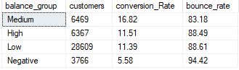
Balance Group – Grouped customers balances into 4 categories to identify which group should be prioritized.
Priority 1: (Medium Balance Group: $1,804 – $5,000): This group holds the highest conversion efficiency at 16.82%. These customers have excess liquidity that they want to grow, but they are not so wealthy that they require complex, specialized wealth management products. A traditional term deposit perfectly matches their need for a safe, predictable return on their savings.
Action: This is CaixaBank primary target. Focus aggressive marketing campaigns here for maximum conversion ROI
Priority 2: (Low Balance Group: $0 – $1,804): Despite a lower Subscription Rate (11.39%) compared to the Medium group, this segment represents the Banks largest customer base by far with 28,609 customers. They will drive a massive portion of the Banks total actual revenue.

Action: Automate outreach to this tier using low-cost channels (like email, SMS, or app notifications) rather than expensive phone campaigns. This keeps acquisition costs low while capturing huge volume.

Priority 3: The Untapped Potential (High Balance Group: $5,000+): This group converts at 11.51%, which is surprisingly low given their high liquidity.

The Insight: Customers with large balances likely find standard term deposit interest rates unappealing. They are probably looking for higher-yield investments (like mutual funds, stocks, or premium treasury bonds).

Action: Do not pitch them a generic term deposit. Instead, pass these leads to a premium banking team to offer tiered, higher-interest rates or bundled wealth products.

Priority 4: High Risk / Avoid (Negative Balance Group: < $0) this group has a dismal 5.58% Subscription Rate and a crushing 94.42% bounce rate.
The Insight: Customers in the negative have no money to lock away into a savings vehicle.
Action: Filter these customers out of term deposit campaigns completely to save time and campaign budget.

- 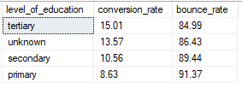
Education Level - Compared Subscription Rate across all level of education.
Priority 1: The Primary Target (Tertiary Education)
The Data: This group leads with the highest Subscription Rate at 15.01% and the lowest bounce rate (84.99%).

The Insight: Customers with a tertiary education (university degrees or higher) are highly receptive. They likely understand the benefits of interest accumulation and have the financial stability to lock away funds.
Action: Prioritize this segment for premium marketing tracks. Use sophisticated financial messaging focusing on yield, portfolio diversification, and long-term asset growth.

Priority 2: The Hidden Opportunity (Unknown Education)
The Data: This segment holds the second-highest Subscription Rate at 13.57%.
The Insight: While we lack data on their specific background, their strong performance makes them too valuable to ignore.
Action: Do not filter them out. Keep them in active marketing pools, and use digital onboarding touchpoints to naturally collect and enrich their missing profile data over time.

Priority 3: The Volume Mass-Market (Secondary Education)
The Data: This segment converts at a lower 10.56%, but in most banking datasets, "Secondary" (high school) represents the largest sheer volume of customers.
The Insight: While less efficient than the tertiary tier, they represent a massive chunk of potential total deposit volume.
Action: Use highly accessible, straightforward messaging. Focus on simple benefits like "zero risk" and "guaranteed returns," and rely on automated, lower-cost marketing channels to maximize total volume without spiking costs.

Priority 4: Low Priority / Restructure (Primary Education)
The Data: This group performs the poorest with an 8.63% Subscription Rate and a crushing 91.37% bounce rate.

The Insight: Customers with only a primary education may face lower liquidity or prefer simpler, immediate cash-access checking accounts over locked term deposits.

Action: Lower the priority of this group for phone outreach. If you do target them, shift the product offering to high-yield flexible savings accounts rather than strict fixed-term deposits.

- 
Marital Status – We checked marital status more like to sign on for term deposit or reject.
Priority 1: The Prime Target (Single)
The Data: This group leads the pack with a 14.95% Subscription Rate and the lowest bounce rate (85.05%).
The Insight: Single individuals generally have fewer combined household financial obligations (like mortgages or children's education funds). This leaves them with higher personal disposable income and the flexibility to lock up their liquidity for a higher return.

Action: Prioritize this segment for targeted digital and mobile banking campaigns. Structure marketing messaging around themes of building personal wealth, saving for future milestones, or maximizing independent financial freedom.

Priority 2: The Moderate Opportunity (Divorced)
The Data: Divorced individuals convert at a moderate 11.95%.
The Insight: This segment often undergoes significant lifestyle and financial transitions, leading them to restructure their personal assets and look for low-risk, stable vehicles to secure their baseline capital.

Action: Maintain steady engagement with this group. Use reassuring, stability-focused marketing angles that highlight the security and guaranteed returns of term deposits.

Priority 3: The Volume Mass-Market (Married)
The Data: Married individuals have the lowest conversion efficiency at 10.12%, with a 89.88% bounce rate.
The Insight: Joint households usually face complex, long-term financial drains (family expenses, childcare, insurance, and home loans). They are highly likely to favor liquid cash accounts or flexible savings options over a rigid, locked term deposit product.

Action: While their Subscription Rate is lower, married couples usually make up the largest overall customer volume in a bank. Instead of expensive calling campaigns, run automated cross-selling tracks that pitch term deposits specifically around joint savings goals (like a kid's college fund).

- 
Default history – Compared conversion and bounce rate and balances of customers with and without a history of credit default. Customer without default history are roughly twice as likely to convert than those with default history.
Priority 1: The Standard Safe Target (No Default History)
The Data: This represents the overwhelming majority of the banks database (44,396 customers). They maintain a standard 11.80% Subscription Rate and hold a massive positive aggregate balance of $61.7M+.
The Pitch Time: Successful conversions in this group happen relatively efficiently, taking an average of 8.93 minutes of call duration.

Action: This remains the banks baseline target. Standard automated and phone campaigns should proceed here uninterrupted.

Priority 2: High Risk / High Friction (Has Default History)
The Data: This group consists of 815 customers with an aggregate negative balance (-$112K+) and a low Subscription Rate of 6.38%.
The Pitch Time: Strikingly, the few customers in this group who do say yes require an average call duration of 11.16 minutes—over two minutes longer than non-defaulted customers.

Action: This group suffers from severe financial strain and requires immense operational effort for a tiny return. Exclude this segment completely from active outbound phone campaigns. The extra 2+ minutes spent on the phone trying to convince a high-risk customer is a poor use of sales capacity.

Personal Loan - Compared conversion and bounce rate and balances of customers with and without a personal loan.
Priority 1: The High-Yield Target (No Personal Loan)
The Data: This group makes up the core numbers (37,967 customers). They convert at a strong 12.66%, holding a massive $55.9M+ in aggregate balance.
The Pitch Time: When they decide to subscribe, they do so efficiently, taking an average of 8.68 minutes on the phone.

Action: This is the banks primary audience pool. They possess the necessary financial liquidity and lower debt obligations to confidently lock away their cash into fixed savings vehicles. Sales team should focus main sales efforts here.

Priority 2: High Friction / Low Return (Has Personal Loan)
The Data: These 7,244 customers hold a drastically lower Subscription Rate of 6.68% and a steep 93.32% bounce rate. Their combined financial balances ($5.6M) are fractionally smaller than the non-loan cohort.
The Pitch Time: Strikingly, the few loan holders who do buy require a massive 11.66 minutes of conversation—nearly 3 minutes longer than the priority tier.

Action: Customers with personal loans are actively paying off debt and are naturally highly resistant to locking up their remaining liquid cash. Given that they take 34% more phone time just to convert at half the rate, deprioritize this group for outbound phone sales.

Housing Loan - Compared conversion and bounce rate and balances of customers with and without a housing loan.
Priority 1: The Prime Target (No Housing Loan)
The Data: This group includes 20,081 customers and boasts a stellar 16.70% Subscription Rate alongside a lower 83.30% bounce rate. They also control the majority of liquidity ($32.0M+ in aggregate balance).

The Pitch Time: Successful sales calls to this group are fast and highly efficient, taking an average of 7.77 minutes.

Action: This is the banks highest-yielding audience. Because these customers are free from heavy monthly mortgage commitments, they possess excess liquidity and are highly receptive to locking away capital. The bank should focus its premier outbound sales agents here.

Priority 2: High Friction / Low Yield (Has Housing Loan)
The Data: This is the banks largest segment (25,130 customers), but it underperforms with a low 7.70% Subscription Rate and a crushing 92.30% bounce rate.

The Pitch Time: Strikingly, the few mortgage holders who do buy require a massive 11.01 minutes of call time—nearly 3.24 minutes longer per successful call than non-mortgage holders.

Action: Mortgage holders prioritize immediate liquid cash for monthly home payments and emergency cushions over locked investments. Given that they consume 41% more phone time just to convert at half the rate, remove this group from cold outbound calling queues.

- 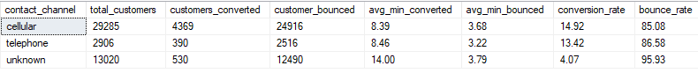
Contact Channel – Identified 3 contact channel customers were reached with.
Cellular: The High-Velocity Revenue Engine:
Cellular is the bank’s core operational channel. It manages 64.8% of all outreach (29,285 contacts) and generates an overwhelming 82.6% of total successful subscriptions (4,369 out of 5,289).

The Strategic Insight: It is highly efficient, holding the highest Subscription Rate at 14.92%. More importantly, successful sales calls are completed rapidly, taking an average of just 8.39 minutes. Rejections happen quickly too (3.68 minutes), meaning sales agents do not waste time on dead ends.

Strategic Priority: CaixaBank must maintain this as its baseline communication channel. It offers the best combination of volume, speed-to-close, and conversion probability.

Telephone (Landlines): Low-Volume Stability:
Traditional landlines represent a tiny fraction of the bank’s campaign (2,906 contacts) but deliver a very solid and stable 13.42% Subscription Rate.

The Strategic Insight: The time-to-close on a successful landline call (8.46 minutes) is virtually identical to a mobile phone call. However, landline users who reject the offer hang up faster (3.22 minutes) than any other group.

Strategic Priority: This channel is highly profitable and clean; it simply lacks scale. Continue utilizing it fully. Because rejections happen so fast, sales agents can burn through landline call lists with minimal wasted overhead.

Unknown Channels:
This is the most critical area for management intervention. "Unknown" contact channels account for 13,020 customers but yield a dismal 4.07% Subscription Rate and a crushing 95.93% bounce rate.

The Strategic Insight: When an untracked or unknown contact method does manage to win a subscription, it takes an astonishing 14.00 minutes—which is 66.8% more talk time than cellular. Because the Subscription Rate is so low, sales team is spending an immense amount of phone time trying to salvage unviable leads on untracked channels.

Strategic Priority: This channel is actively draining the banks marketing budget and wasting valuable sales hours. These are likely poorly logged outreach attempts or unoptimized legacy scripts where agents are over-pitching resistant customers.
Immediate Action Plan/Recommendation for the Management
KEY Recommendation to stakeholders:
- Enforce Strict System Validation: CaixaBank must implement a data-governance rule in its CRM that blocks agents from submitting or launching campaigns against accounts missing a specified contact channel type. We must eliminate the "Unknown" bucket.
- Implement a "Talk-Time Cap" Rule: Since "Unknown" calls stretch to 14 minutes, mandate that if a call on an unverified channel crosses the 9-minute mark without a clear commitment or closing path, the agent must politely end the call to reclaim sales capacity.
- Migrate Landlines to Mobile Tracks: During successful landline calls, instruct agents to request a mobile number to naturally migrate these highly stable customers into the banks high-volume digital or automated SMS/app messaging streams.

- 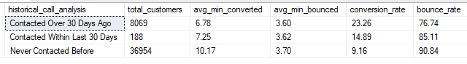
Days since last contact (-1 ⇒ never) – Compared customers behavior toward intervals of calls received during the campaign. To understand which customers to prioritize when following – new leads or existing customers.
Contacted Over 30 Days Ago: The Sweet Spot for Conversions
The Data: This group includes 8,069 customers and leads with a massive 23.26% Subscription Rate.
The Operational Value: At 6.78 minutes, this group has the fastest closing speed in the entire database. It takes 33.3% less phone time to convert these warm leads than completely new customers.

The Strategic Insight: These customers are familiar with the bank but have been given enough time to breathe since their last campaign. The combination of previous familiarity and a lack of immediate "marketing fatigue" make them the highest-yielding asset.

Contacted Within Last 30 Days: The Over-Saturated Segment
The Data: This is a very small pool (188 customers) converting at a moderate 14.89%.

The Strategic Insight: While a 14.89% Subscription Rate is still higher than the database baseline, the incredibly small customer volume shows CaixaBank team is rarely calling people back within the same month. This is a good practice, as calling too frequently triggers ad fatigue and burns leads.

Never Contacted Before: High Operational Friction & Low Yield
The Data: This is the massive core of CaixaBank database (36,954 customers), but it performs poorly with a low 9.16% Subscription Rate and a staggering 90.84% bounce rate.

The Operational Value: Cold leads require an average of 10.17 minutes just to close a single deal.

The Strategic Insight: Cold outreach is incredibly expensive. CaixaBank agents are spending the longest time on the phone (over 10 minutes) on a population where 9 out of 10 people will ultimately hang up or reject the offer.

Immediate Action Plan for the Management & Stakeholders
Recommendations to maximize sales capacity and campaign ROI:
- Prioritize "Warm-Up" Lead Lists: In the banks call center routing software, accounts where pdays > 30 should be prioritized. They close 33% faster and convert at more than double the rate of a cold list.
- Build an Automated Lead Nurturing Funnel for New Customers: Stop using expensive live agents for the initial cold contact of the 36,954 "Never Contacted" group. Instead, use automated email or SMS marketing tracks to introduce the term deposit product. Once a customer clicks a link or shows interest, pull them into the active calling queue as a warm lead.
- Maintain the 30-Day Rest Period: Keep the policy of avoiding immediate call-backs within 30 days, as the data shows CaixaBank current volume there is tiny and controlled.

Recency and familiarity dramatically increase a customer's willingness to subscribe, while completely new leads require massive, costly operational effort for a very low return.

Previous contacts before this campaign - Compared customers behavior who had previously received calls from the bank for term deposit vs. new leads who hadn’t been called before. Existing relationship leads are more than twice as easy to convert as brand-new leads, but new leads require significantly more effort.
The Conversion Multiplier (23.07% vs. 9.16%)
- Historical Leads: Customers who have been contacted in previous campaigns convert at a high rate of 23.07%. This means nearly 1 in 4 existing leads says "yes."
- Brand New Leads: Leads with zero past contacts convert at just 9.16% (fewer than 1 in 10).

The Strategic Value: Brand equity and familiarity are highly powerful. A customer who already knows CaixaBank is 2.5 times more likely to buy a term deposit than a cold lead.

The Conversation Fatigue Gap (6.79 min vs. 10.17 min)
- Historical Leads: To get a successful subscription from an existing lead, call agents only need to speak with them for an average of 6.79 minutes. They already trust the brand, so the sales pitch can be short and direct.
- Brand New Leads: To win a subscription from a brand-new lead, call agents have to talk for a massive average of 10.17 minutes!
The Strategic Value: Cold leads require 50% more phone time just to establish trust, handle objections, and explain the product from scratch. This represents a heavy drain on call center labor capacity.

The Rejection Consistency (3.60 min vs. 3.70 min)
- Whether a lead is new or old, when they decide to say "no" (bounce), they do it quickly—in about 3.6 to 3.7 minutes. This shows that CaixaBank sales agents are doing a great job identifying hard rejections early in the call without wasting excessive time.

Immediate Action Plan for the Management & Stakeholders
- Prioritize the Historical Funnel: The bank should strictly exhaust all historical campaign lists before launching cold outreach. Warm leads yield a 2.5x higher sales return in much shorter time frames.
- Revamp the "New Lead" Pitch: Because new leads drag out calls to over 10 minutes, the scripting for cold audiences is too long or overly complex. Marketing needs to design a simpler, low-friction initial hook to get new leads interested faster.
- Reallocate Agent Capacity: Assign CaixaBank most experienced, high-performing sales agents to the Brand New Lead pool (where the sales friction is highest) and allow junior agents or automated channels to handle the high-converting Historical Leads.

"Our relationship equity is so strong that nearly 1 in 4 existing leads says yes, whereas our cold reach requires massive effort just to get fewer than 1 in 10 to convert."

.
- 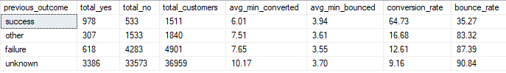
Outcome of previous campaign [poutcome] – Measured Subscription Rate of previous campaign between existing vs new customers.
The Super-Converter Group: Previous "Success"
The Data: Customers who said "yes" in the last campaign convert at a staggering 64.73% in this current campaign. This is roughly 2 out of every 3 people saying yes (\(64.73\% \approx 2/3\)).

The Effort Insight: This segment of customers require the shortest talk time to win a conversion (only 6.01 minutes). They already love Caixa products and trust the team, so they buy again with minimal friction.

The Persistence Group: Previous "Failure"
The Data: Customers who rejected the bank in the last campaign (failure) were called again anyway. Surprisingly, they converted at 12.61% this time around.

The Insight: This 12.61% is actually higher than the bank's baseline campaign average (11.70%). It proves that a "no" in marketing is often just a "not right now." Changes in a customer's life or financial needs mean they can still be flipped into a win later on.

The Dangerous Blind Spot: Previous "Unknown"
The Data: This group makes up 81.7% of CaixaBank entire dataset (36,959 out of 45,211 customers). They have a rock-bottom Subscription Rate of 9.16% and an absolute maximum bounce rate of 90.84%.

The Effort Insight: Winning a customer here takes a painful 10.17 minutes of talk time on average.

The Insight: This group completely mirrors the "Brand New Leads" data from CaixaBank previous query. Because the bank knows absolutely nothing about their history, sales agents are flying completely blind, dragging out phone conversations, and getting rejected 9 times out of 10.

Three Major Strategic Immediate Action Plan for The Management & Stakeholders
- Establish a "VIP Priority Queue": Instantly move the 1,511 historical "Success" leads to the very front of the line. They yield a massive 64.73% Subscription Rate with almost zero resistance. If the bank rolls out a new product, these people must always be called first.
- Do Not Delete Past Failures: Keep routing previous campaign "Failures" back into CaixaBank outbound queues. A 12.61% success rate means they are still highly valuable prospects who simply required better timing or a different seasonal offer.
- Invest in Missing Data Enrichment: The "Unknown" category is completely overwhelming CaixaBank call center capacity. If the bank can invest in data mining to uncover what these 36,959 customers bought in the past, they can move them out of the high-friction 9% conversion trap and build smarter targeted segments.

"Look at our previous success group. The relationship momentum is so massive that nearly 2 out of every 3 of these customers subscribe immediately when we call them back!"

- 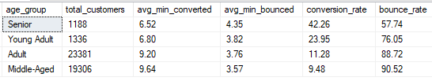
Age group Analysis - Analyzed which age group performed better for subscription to term deposits.
(Seniors & Young Adults)
- Seniors: This is the banks best performing segment. They have an elite 42.26% Subscription Rate (roughly 2 out of 5 people say "yes"). Even better, they make up their minds incredibly fast, requiring the shortest conversion talk time at just 6.52 minutes.

- Young Adults: This group is the runner-up with a strong 23.95% Subscription Rate (nearly 1 in 4 say "yes"). They also make quick decisions, converting in just 6.80 minutes.

- The Operational Reality: Despite being the banks absolute best segments, the marketing team barely targeted them. Together, Seniors and Young Adults make up less than 6% of total customers contacted (2,524 out of 45,211).

(Adults & Middle-Aged)
- The Data: The bank poured 94.4% of its total call volume (42,687 customers) into these two groups.
- The Friction: Their Subscription Rates drop significantly to 11.28% for Adults and a rock-bottom 9.48% for the Middle-Aged.
- The Effort Drag: To win a subscription from these groups, CaixaBank sales agents are forced to stay on the phone for 9.20 to 9.64 minutes per successful call. This represents a massive waste of call center labor for very low returns.

Major Strategic Immediate Action Plan For The Management & Stakeholders;
Pivot the Campaign Audience: Aggressively expand marketing lists for Seniors and Young Adults. They are highly receptive to term deposits. Seniors likely value safe, guaranteed interest yields, while Young Adults may be opening their first savings accounts.

- Fix the Middle-Aged Strategy: Stop mass-calling the Middle-Aged segment with generic pitches. This group is likely focused on heavy expenses (mortgages, children's education) and finds locked term deposits unattractive. They need highly specific, high-yield messaging to move their Subscription Rate past 9.48%.
- Optimize Call Center ROI: Shifting calls from Middle-Aged prospects to Seniors saves over 3 minutes of agent talk time per sale while multiplying the likelihood of a conversion by 4.4x (\(42.26\% \div 9.48\%\)).

Total Campaign Hours Spent by Age Group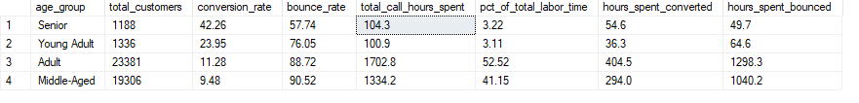
We splits the call center hours by customer reaction. Analysis show that the bank spent 2,338.5 hours listening to rejections from just two groups: Adults and Middle-Aged customers. 94% of the Labor Budget Was Wasted: Out of 3,243.5 total hours spent by agents on the phone, 3,038.2 hours were burned on Adults and Middle-Aged prospects, who yielded Subscription Rates near or below 11%. Seniors Were Starved of Time: High-converting Seniors (42.26% success rate) were given a tiny 104.3 hours of call time.

Strategic Immediate Action Plan for The Management & Stakeholders
The Middle-Aged: The call team spent a massive 2,338.5 hours on the phone with Adults and Middle-Aged customers who ultimately said "no" (hours_spent_bounced).

The Operational Impact: This is 72% of the banks entire campaign's labor budget completely down the drain. Agents spent more time listening to rejections from these two groups than they spent talking to every single successful converter in the entire campaign combined.

Efficiency Champions (Seniors vs. Middle-Aged)
Seniors: Out of 104.3 total hours spent calling Seniors, 54.6 hours were spent on successful conversions. Over half of their phone time resulted in revenue!
Middle-Aged: Out of 1,334.2 hours spent on Middle-Aged customers, a tiny 294 hours resulted in a sale.
The Contrast: CaixaBank team spent nearly 4.5 times more hours trying to convert Middle-Aged customers than Seniors, but got back an overwhelming wall of rejections.
"Right now, we are wasting 94% of our campaign budget on audiences that give us a 9% return. If we reallocate those phone calls to our Senior segment, every single call we make is 4.5 times more likely to result in a successful sale."

- 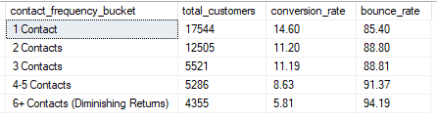
Contact frequency analysis – Analyzed and compared the marketing team call efficiency. Analysis of the campaign column, which tracks how many times a customer was called during this active campaign, and maps it against their ultimate Subscription Rate.
The Peak Opportunity Window (1 Contact)
The Data: CaixaBank absolute highest Subscription Rate happens on the 1st Contact at 14.60%.

The Strategy: Over 38% of CaixaBank entire customer pool (17,544 out of 45,211) falls into this bucket. This is where CaixaBank customer is freshest, most receptive, and least annoyed by outbound dialing.

The Conversion Plateau (2 to 3 Contacts)
The Data: The moment you call a customer a second time (2 Contacts), CaixaBank Subscription Rate drops significantly to 11.20% and completely flatlines through the third call (11.19%).
The Insight: If a customer does not buy on the first call, a second and third call yield an identical, lower level of interest. You are putting in double or triple the calling effort for a lower probability of success.

The Dangerous Cliff of Diminishing Returns (4+ Contacts)
4–5 Contacts: Conversion drops down to a single digit (8.63%), while the bounce rate climbs past 91%.
6+ Contacts: This is pure resource waste. The Subscription Rate bottoms out at 5.81%, while the rejection rate skyrockets to a painful 94.19%.

The Over-Call Reality: CaixaBank team spent time dialing 4,355 customers six or more times. That represents thousands of repeated phone calls that resulted in a "no" nearly 95% of the time.

Strict policy recommendations For Management & Stakeholders:
- Enforce a Hard Campaign Cap: Institute an immediate "3-Strike Rule" in the call center's dialer software. Once a customer has been called 3 times during a campaign without converting, they must be automatically removed from the active queue.
- Reallocate Dialer Power to Fresh Leads: The time spent making 4th, 5th, or 6+ calls to cold prospects should be entirely redirected toward calling brand-new leads for their 1st Contact, where the Subscription Rate is 2.5 times higher.
- Change Channels for Multi-Call Prospects: If a customer is highly valuable but hasn't responded by the 2nd phone call, stop calling them. Switch them to a lower-cost automated digital channel, such as a targeted email or SMS offer, to protect CaixaBank sales team's live talk time.

- 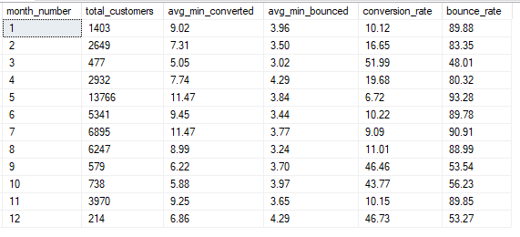
Month Comparison - Compared which month performed better in previous campaign with better Subscription Rate.
The seasonal marketing analysis uncovered a massive operational mismatch in the banks marketing schedule. It maps month_number (January to December) against campaign success, revealing that the bank is flooding the phones during its lowest-performing months while completely starving its peak high-yield periods.

The High-Yield Goldmines (March, September, October, December)
The Data: CaixaBank absolute highest Subscription Rates happen in March (51.99%), September (46.46%), October (43.77%), and December (46.73%). During these times, roughly 1 out of every 2 customers called says "yes."

Efficiency: Successful conversations are incredibly fast. In March, it takes an average of just 5.05 minutes to secure a deposit subscription.

The Problem: The marketing team completely ignored these months. Combined, they make up a tiny 4.4% of total campaign volume (2,008 out of 45,211 customers).

The Great "May" Disaster (Month 5)
The Data: In May, call volume explodes to a staggering 13,766 customers—accounting for 30.4% of the entire annual campaign.

The Friction: Despite the massive effort, May yields a rock-bottom Subscription Rate of just 6.72% and a painful bounce rate of 93.28%.

The Labor Drain: To win a single subscription in May, agents have to stay on the phone for an average of 11.47 minutes (the longest across all 12 months). The team is working at peak exhaustion for minimal returns.

The Mid-Year Plateau (June, July, August)
The high-volume summer period (nearly 18,500 calls) is highly stagnant. Subscription Rates hover between 9% and 11%, heavily dragging down overall call center ROI.

Major strategic actions For The Management & Stakeholders:
- Flatten the May Call Spike: Immediately cut May's outbound dialing targets by at least 50% next campaign. The market is clearly oversaturated or unreceptive to term deposits in late spring (likely due to tax season adjustments or summer vacation planning).

- Shift Volume to End-of-Quarter/Year Windows: Reallocate those raw calling hours to March, September, and October. Customers during these months are highly motivated to lock in savings rates (likely aligning with fiscal corporate quarters and personal year-end planning).

- Capitalize on Short Call Windows: Because March and October conversions take under 6 minutes, agents can handle double the call volume in the same shift compared to May, multiplying total sales velocity.

- 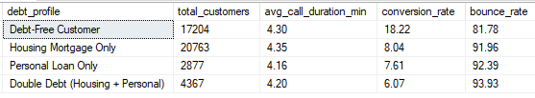
Financial Risk Analysis - The liquidity and disposable income of a customer completely dictate their willingness to buy a term deposit. This data cross-analyzes the housing (mortgage) and loan (personal loan) columns to show how a customer's active debt obligations crush their ability to participate in savings products.
Debt-Free Customers
The Data: Customers with absolutely no outstanding debt convert at 18.22%. This is CaixaBank most responsive and lucrative segment.

The Insight: Nearly 1 in 5 debt-free customers says "yes." Because they are not burning cash on monthly interest payments, they have surplus capital available to lock away into the bank’s term deposits to earn interest.

Housing, Personal, & Double Debt
The Single-Debt Drop: The moment a customer takes on either a Housing Mortgage Only (8.04%) or a Personal Loan Only (7.61%), their likelihood to buy a term deposit plummets by more than half.

The Double-Debt Floor: For customers drowning in Double Debt (6.07%), conversion hit rock bottom. A staggering 93.93% of these calls result in a bounce. They simply do not have spare cash to lock up because their monthly income is consumed by debt servicing.

The Call Duration Paradox
The Data: The avg_call_duration_min is nearly identical across all groups, hovering tightly between 4.16 and 4.35 minutes.

The Insight: Debt profiles do not change how long a customer stays on the phone with CaixaBank team. This means CaixaBank agents are spending the exact same amount of energy, breath, and labor on a Double Debt customer as they are on a Debt-Free customer, but getting 3 times less revenue for that effort.

Strategic Recommendation
Debt-profile breakdown to the product and marketing executives and major strategic actions:
- Implement Strict Pre-Call Filtering: Instantly modify CaixaBank data extraction queries to exclude or deprioritize "Double Debt" and "Personal Loan" segments from outbound term deposit campaigns. Reallocate those thousands of dials to CaixaBank Debt-Free target list.
- Cross-Sell a Different Product to Debt Heavy Lists: Stop trying to sell savings products to people who owe money. Instead of pitching a term deposit to the 4,367 Double Debt customers, route them to a Balance Transfer, Debt Consolidation, or Refinancing campaign where the bank can offer to lower their interest rates.
- Tailor the Value Proposition for Mortgage Holders: For the massive "Housing Mortgage Only" pool (20,763 customers), change the sales script. Instead of standard savings messaging, pitch the term deposit as a "Mortgage Offset or Safety-Net Fund" to see if that framing can push them past the low 8% conversion barrier.

- 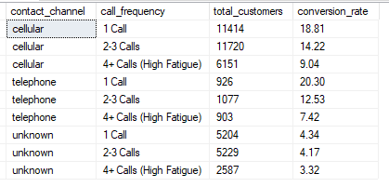
Contact Channel Call Frequency Cross Analysis– Compared contact channel used to reach customer.
The Telephone Paradox (High Initial Success, Rapid Decline)
The Data: The highest single-touch Subscription Rate is actually over traditional Telephone (20.30%) on the 1st call.

The Problem: It experiences the absolute worst fatigue drop-off. By the time an agent reaches 4+ Calls, the telephone Subscription Rate collapses by nearly two-thirds down to 7.42%.

The Insight: Traditional landlines or corporate desk phones are excellent for reaching people who answer immediately, but repeating calls to these lines quickly alienates the prospect.

The Cellular Workhorse (High Volume, Most Resilient)
The Data: Cellular is CaixaBank structural baseline, capturing nearly 65% of the total dataset. It delivers a strong 18.81% conversion on the first call.
The Value: Mobile users are the most tolerant of multiple touches. Even at 4+ Calls, cellular leads maintain a 9.04% Subscription Rate—which is higher than telephone or unknown channels at any frequency bucket.

The "Unknown" Dead Zone (Data Completeness Failure)
The Data: For over 13,000 customers, the bank has an unknown communication channel. The Subscription Rates here are abysmal, peaking at a tiny 4.34% on the first call and dropping to 3.32%.
The Operational Reality: Trying to brute-force these leads with more phone calls is entirely useless. The conversion gap between 1 call (4.34%) and 4+ calls (3.32%) is statistically flat. You are burning massive agent labor dialing numbers with corrupted, out-of-date, or blocked metadata.

Investigating Data Integrity: Investigated the volume of "Unknown" data points across four critical dimensions (education, job, contact, and poutcome) and highlights the actual conversions hidden inside those data blind spots.
The numbers reveal that data gaps are costing CaixaBank massive efficiency leaks, particularly in the Contact Channel and Prior Outcome fields.
Missing Context Monolith (poutcome & contact)
- Previous Outcome (poutcome): A massive 36,959 rows are marked as unknown. While this group generated 3,386 subscriptions, their Subscription Rate is a low 9.16% (3,386 ÷ 36,959). This confirms that when the bank doesn't track a lead's historical relationship, agents are flying blind and getting rejected 91% of the time.

- Contact Channel (contact): An overwhelming 13,020 rows have no recorded contact method. They only yielded 530 subscriptions—a terrible Subscription Rate of 4.07% (530 ÷ 13,020). These are likely dead-end, unoptimized records that are burning agent calling hours.

The High-Yield Profile Gaps (education & job)
- Education: Only 1,857 rows are missing education data, but they generated 252 subscribers. That is a surprisingly high Subscription Rate of 13.57% (252 ÷ 1,857), which is higher than the overall campaign average of 11.70%.

- Job: A tiny sliver of the data (288 rows) has an unknown job title, yielding 34 subscribers (11.81% Subscription Rate).

- The Insight: Missing demographic data (education or job) doesn't hurt CaixaBank sales as badly as missing operational data (contact or poutcome). Customers with blank jobs or degrees still buy at standard rates; customers with blank communication histories do not.

Major Strategic Actions For The CRM Data Management Team, Marketing Executives, The Management & Stakeholders:
Enforce Mandatory System Logging: The fact that 13,020 records have an "unknown" contact channel implies that agents are manually dialing numbers without the CRM logging if it was a mobile phone or a landline. System architecture must be updated to force-log the channel type upon a call connecting.
Do Not Discard Missing Demographics: Keep calling leads with unknown jobs or education profiles. Their 11%–13% Subscription Rates prove they are still highly viable prospects; the bank simply needs an "enrichment campaign" to update their profiles during the live conversation.

Isolate the Unknown Historical Funnel: The 3,386 subscribers sitting inside the unknown poutcome bucket represent a major retention risk. Once a customer from this blind-spot pool says "yes," their profile must instantly be updated to "Success" so they are accurately categorized for the next campaign.

